# ECEN 240 Lab 5 – Road Ripper Motor Company

# Name:

# ____________________________________________________________________________________

# Purpose:

1. To design and implement a circuit consisting of 4 inputs and 4 outputs.
2. Successfully derive a Boolean equation from a truth table using K-Maps.
3. Implement the simplified equation using a digital simulation program using gates.
4. Implement the truth table using a ROM in Logisim.
5. Implement the simplified equation using a hardware description language and a Field Programmable Gate Array (FPGA).

# Project Scenario:

**R2**

## ___/------\___

**--O--------O--**

**Road Ripper Motor Company**

You have accepted a job with the Road Ripper Motor Company. Your first task is to upgrade the Road Ripper Motor Company’s blinker and brake light system to a fully digital system.

Below is a truth table specification of what each light should do when the break is depressed (STOP input) and when the turn signal switches are activated (LEFT and RIGHT switches). The outputs are the front and rear lights on our cars.

|  |  |  |  |  |  |  |  |
| --- | --- | --- | --- | --- | --- | --- | --- |
| Input (Switches) | | |  | Outputs (Lights) | | | |
| STOP | LEFT | RIGHT |  | L_FRONT | L_BACK | R_FRONT | R_BACK |
| 0 | 0 | 0 |  | 0 | 0 | 0 | 0 |
| 0 | 0 | 1 |  | 0 | 0 | BLINK | BLINK |
| 0 | 1 | 0 |  | BLINK | BLINK | 0 | 0 |
| 0 | 1 | 1 |  | BLINK | BLINK | BLINK | BLINK |
| 1 | 0 | 0 |  | 0 | 1 | 0 | 1 |
| 1 | 0 | 1 |  | 0 | 1 | BLINK | BLINK |
| 1 | 1 | 0 |  | BLINK | BLINK | 0 | 1 |
| 1 | 1 | 1 |  | BLINK | 1 | BLINK | 1 |

0 = OFF 1 = ON BLINK = Blinking (Clocked)

In the above truth table “Blink” describes the action of the car’s turn signals, but “BLINK” is not a valid logic level. To generate a signal that can turn on and off like a blinker, we can add a clock to inputs. A clock is a signal that alternates between a “1” and “0” in a periodic (repetitive) fashion. The CLOCK signal is incorporated into the modified truth table below:

|  |  |  |  |  |  |  |  |  |
| --- | --- | --- | --- | --- | --- | --- | --- | --- |
| Inputs | | | |  | Outputs (Lights) | | | |
| STOP | LEFT | RIGHT | CLOCK |  | L_FRONT | L_BACK | R_FRONT | R_BACK |
| 0 | 0 | 0 | 0 |  | 0 | 0 | 0 | 0 |
| 0 | 0 | 0 | 1 |  | 0 | 0 | 0 | 0 |
| 0 | 0 | 1 | 0 |  | 0 | 0 | 0 | 0 |
| 0 | 0 | 1 | 1 |  | 0 | 0 | 1 | 1 |
| 0 | 1 | 0 | 0 |  | 0 | 0 | 0 | 0 |
| 0 | 1 | 0 | 1 |  | 1 | 1 | 0 | 0 |
| 0 | 1 | 1 | 0 |  | 0 | 0 | 0 | 0 |
| 0 | 1 | 1 | 1 |  | 1 | 1 | 1 | 1 |
| 1 | 0 | 0 | 0 |  | 0 | 1 | 0 | 1 |
| 1 | 0 | 0 | 1 |  | 0 | 1 | 0 | 1 |
| 1 | 0 | 1 | 0 |  | 0 | 1 | 0 | 0 |
| 1 | 0 | 1 | 1 |  | 0 | 1 | 1 | 1 |
| 1 | 1 | 0 | 0 |  | 0 | 0 | 0 | 1 |
| 1 | 1 | 0 | 1 |  | 1 | 1 | 0 | 1 |
| 1 | 1 | 1 | 0 |  | 0 | 1 | 0 | 1 |
| 1 | 1 | 1 | 1 |  | 1 | 1 | 1 | 1 |

**Lab 5 Part 1**

Determine the Boolean equations for the brake lights and turn signals using K-Maps. Use the letters S, L, R, and C (Stop, Left, Right, and Clock) for the inputs in the Boolean expressions.

K-Maps – Complete K-map for each signal (make loops by changing text colors, shading with colors, or by using patterns).

Fill out the Karnaugh map for the **left front** light:

|  |  |  |  |  |
| --- | --- | --- | --- | --- |
| SL  RC | 00 | 01 | 11 | 10 |
| 00 |  |  |  |  |
| 01 |  |  |  |  |
| 11 |  |  |  |  |
| 10 |  |  |  |  |

Fill out the Karnaugh map for the **left back** light:

|  |  |  |  |  |
| --- | --- | --- | --- | --- |
| SL  RC | 00 | 01 | 11 | 10 |
| 00 |  |  |  |  |
| 01 |  |  |  |  |
| 11 |  |  |  |  |
| 10 |  |  |  |  |

Fill out the Karnaugh map for the **right front** light:

|  |  |  |  |  |
| --- | --- | --- | --- | --- |
| SL  RC | 00 | 01 | 11 | 10 |
| 00 |  |  |  |  |
| 01 |  |  |  |  |
| 11 |  |  |  |  |
| 10 |  |  |  |  |

Fill out the Karnaugh map for the **right back** light:

|  |  |  |  |  |
| --- | --- | --- | --- | --- |
| SL  RC | 00 | 01 | 11 | 10 |
| 00 |  |  |  |  |
| 01 |  |  |  |  |
| 11 |  |  |  |  |
| 10 |  |  |  |  |

**Refresher on Minterm Mapping**

|  |  |  |  |  |
| --- | --- | --- | --- | --- |
| SL  RC | 00 | 01 | 11 | 10 |
| 00 | m0 | m4 | m12 | m8 |
| 01 | m1 | m5 | m13 | m9 |
| 11 | m3 | m7 | m15 | m11 |
| 10 | m2 | m6 | m14 | m10 |

Make sure you understand how the minterms, m0-m15, are mapped to the above K-maps.  
List the minterms that are present in the prime implicant loops (m0, m1, …):

|  |
| --- |
| **left front** = m( ) |

|  |
| --- |
| **left back** (loop that includes m5) = m( ) |

|  |
| --- |
| **left back** (loop that includes m8) = m( ) |

|  |
| --- |
| **left back** (loop that includes m14) = m( ) |

|  |
| --- |
| **right front** = m( ) |

|  |
| --- |
| **right back** (loop that includes m3) = m( ) |

|  |
| --- |
| **right back** (loop that includes m8) = m( ) |

|  |
| --- |
| **right back** (loop that includes m14) = m( ) |

**Boolean Reduction**

What is the reduced Boolean equation for the left front light?

|  |
| --- |
| L_Front = |

What is the reduced Boolean equation for the left back light?

|  |
| --- |
| L_Back = |

What is the reduced Boolean equation for the right front light?

|  |
| --- |
| R_Front = |

What is the reduced Boolean equation for the right back light?

|  |
| --- |
| R_Back = |

***To Verify Your Design, Take Lab 5 Quiz 1***

(Quiz is worth 15 points)

**Lab 5 Part 2**

(You should have taken Lab 5 Quiz 1 before implementing in Logisim)

**Version 1 of the Road-Ripper Circuit:Use AND, OR and NOT Gates**

Implement the reduced Boolean equation in *Logisim* using AND, OR, and NOT gates. Use the following pin names:

|  |  |
| --- | --- |
| Input Names | Output Names |
| Stop | L_Front |
| Left | L_Back |
| Right | R_Front |
| Clock | R_Back |

You will find that you can simplify the Logisim circuit by noticing that one of the product terms in the L_Back signal is generated by the L_Front signal. Also, one of the product terms in the R_back signal is generated by the R_Front signal.

Make your schematic nice and neat (construction quality will affect the score you receive).

Place your name under your circuit (make it large enough to read)

You should verify the circuit functionality by manually testing the input combinations shown in the original truth table.

Once you are convinced your *Logisim* implementation is correct, demonstrate its functionality using the “test vector” tool available in the *Simulate* menu of *Logisim Evolution*.

* Download the test file called “Road_Ripper_test.txt” found in the Lab3 module in *I-I-Learn*.
* Place the file in your *Logisim Evolution* folder.
* Run the “Test Vector” tool from the “Simulate” menu of *Logisim Evolution*.
* Select “Load Vector” and navigate to the “Road_Ripper_test” file.
* The tool will display a truth table showing the tests that passed and the tests that failed. Keep working on your circuit until there are no failures.
* Take a “snapshot” of the window showing your test results, and paste the snapshot in the submission box below:

## (The “test vector” border box will expand to fit a screen-shot of your test results)

|  |
| --- |
|  |

## Road Ripper Test Vector Results with “AND, OR, NOT” Gates (10 points)

## Take a “snapshot” of the circuit (including your name), and paste the snapshot in the submission box below:

## (The circuit boarder box should expand to fit the size of your screen-shot)

|  |
| --- |
|  |

## Logisim Evolution Circuit with “AND, OR, NOT” Gates (10 points)

**Version 2 of the Road-Ripper Circuit:Use a ROM to build the circuit**

Implement the reduced Boolean equation in *Logisim* using a ROM (Use a single ROM and no other gates). A ROM (Read Only Memory) acts very much like a truth table, so the entire truth table may be entered into the ROM.

The *Logisim* ROM is found in the "Memory" folder. The address bit width should be set to 4 bits (each address bit serving as one of four input signals). The data bit width will also be set to 4 bits (each data bit serving as one of the four output signals):



A ROM with 4 address bits has 24 memory locations, and each memory location in this ROM is set to store 4 bits. The *Logisim* *Evolution* symbol for the ROM looks like this:

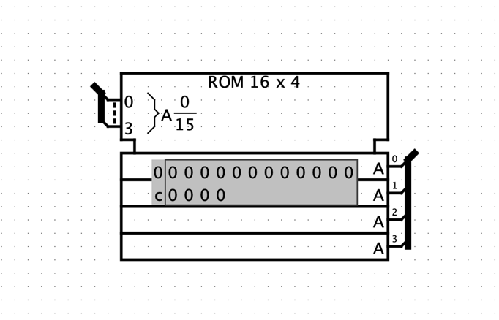

Notice that the ROM Address input is at the upper left of the symbol, and it appears that all 4 address bits are merged into a single wire “bundle”. This is called a “bus” and makes schematic diagrams easier to read. The “Data” output is at the bottom right of the symbol, and all four outputs are merged into a single bus, as well. To access each wire in a bus, you will need to use a “splitter” from the wiring menu of *Logisim*.

Place a splitter in your circuit, and set the options to:



Move the splitter into position as shown:

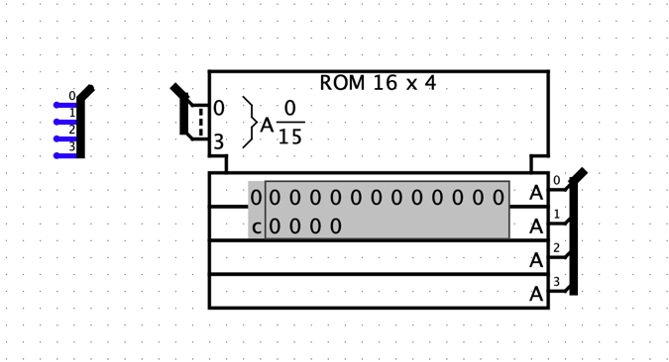

The “0” on the splitter represents the Least Significant Bit (LSB) and the “3” on the splitter represents the Most Significant Bit (MSB). The LSB corresponds to the “Clock” signal (C), and the MSB corresponds to the “Stop” signal (S).

Connect the respective signals as shown:



To connect the outputs, your will need the splitter to be oriented “West” instead of “East”.

Remember to connect the output signals to the proper splitter pin, and add your name below the ROM circuit.

By default, there is no data stored in memory. There are a couple of ways to program Logisim ROMs. One way is to use the poke tool (the hand with the index finger extended). Select the poke tool, select the ROM, then select the cell you want to edit and type a hexadecimal value. The other way to edit the contents of the ROM is to select the ROM with the edit tool and then in the “Selection: ROM” window, click the “(click to edit)” item in the “Contents” row of the window. This pops up a “Logisim: Hex Editor” window. Select the cell you want to edit in the Hex Editor and enter a hexadecimal value. You can save the contents of the hex editor to a file and open files from which you can read into the hex editor.

The value in using a ROM to implement your truth table is that there is no need for simplification. Simply enter the output data from the truth table into the proper address location!

You should verify the circuit functionality by manually testing the input combinations shown in the original truth table.

Once you are convinced your *Logisim* implementation is correct, demonstrate its functionality using the same test vector file you used for the AND, OR, NOT implementation. Paste a snapshot of the results below:

(The “test vector” border box will expand to fit a screen-shot of your test results)

|  |
| --- |
|  |

Road Ripper Test Vector Results with ROM (10 points)

Take a “snapshot” of the circuit (including your name), and paste the snapshot in the submission box below:

(The circuit box should expand to fit the size of your screen-shot)

|  |
| --- |
|  |

*Logisim Evolution* Circuit with ROM (10 points)

**Lab 5 Part 3**

Vivado Tutorial

Complete the Lab5 Vivado Tutorial (instruction document found in the module for this lab).

|  |
| --- |
|  |

Screenshot of the elaborated design schematic (10 points)

(Note that there is a difference between the “elaborated” schematic and the “synthesized” or “implemented” schematic. Make sure to note the difference, but place only the elaborated design in the above box)

|  |
| --- |
|  |

Your SystemVerilog module code (10 points)

***To Pass off your design, take Lab 5 Quiz 2***

(Quiz is worth 10 points)

**Conclusions Statement**

Write a brief conclusions statement that discusses the original purposes of the lab found at the beginning of this lab document.

* What are the difficulties related to designing a 4-input, 4-output circuit?
* What are your thoughts on using K-maps VS Boolean Equations to simplify logic problem?
* Compare implementing a circuit with logic gates to implementing a circuit with a programmable logic device (like a ROM).
* Describe your first impressions about using SystemVerilog to program an FPGA in the Vivado Environment. How does this compare with building your circuit on a breadboard?

Please use complete sentences and correct grammar to express your thoughts:

(The conclusions box will expand as you write)

|  |
| --- |
|  |

Conclusions Statement (15 points)

Congratulations, you have completed the lab!

You may now submit this document.